MA 323 (2020) Monte Carlo Simulation Lab 06

**Name:** Udandarao Sai Sandeep

**Roll Number:** 180123063

**Dept.:** Mathematics and Computing

**Q1.**

Firstly, 1000 values from the distribution *Z ∼ N (0, I2)* were generated using the Box-Muller Method. For each different value of a, Sigma Covariance matrix was obtained (as given in question1). Using Cholesky Factorization for two variables, the matrix A (such that AAT = Σ) was obtained for each case. From the Linear Transformation Property, we know that if *X = μ+AZ*, then *X ∼ N (μ, AAT).* Using this property, 1000 samples of X were generated. (It can be noted that *X ∼ N (μ, Σ)* as AAT = Σ). Hence, the required distribution has been obtained.

**Q2.**

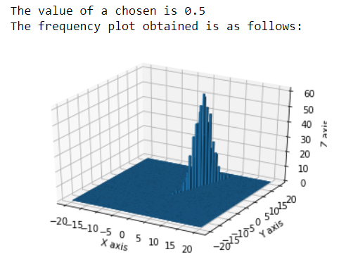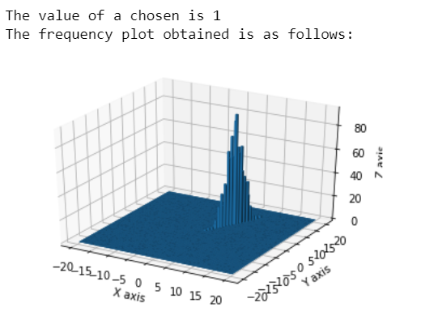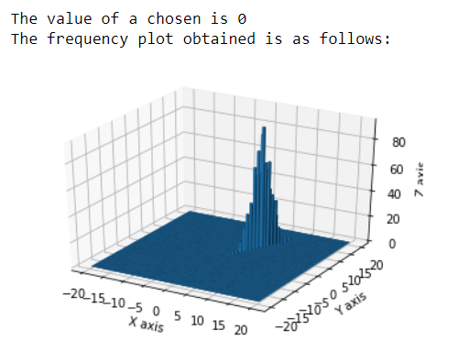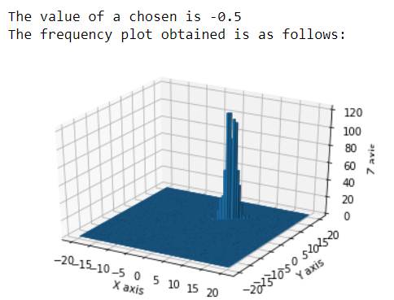Using the values generated, a 3d frequency histogram was created (in python using the mpl_toolkits module) for each case, where the X-axis represents X1, where the Y-axis represents X2, and the Z-axis represents the frequency of a particular bin. (It is important to note that the bins are uniformly spread over the mesh generated by X and Y axis). For this particular question, number of bins was set to 100. Range of the mesh grid is set to [-20,20] x [-20,20]. The plots obtained are as follows:

It can be seen that all the graphs resemble bivariate normal distributions with mean [5,8]. In the first 3 cases (a = 0.5, a = - 0.5, a = 0), the value of a is given such that all the Sigma Covariance Matrices are non singular (positive definite) and hence, the frequency histograms were obtained. But, for the case a = 1, Sigma Covariance Marix is a singular matrix (determinant is 0). Since we have defined X as X = μ+AZ (and not in terms of a density function), a frequency histogram is obtained for this case also (as seen above.)

**Q3.**

**Two-Dimensional Case:**

**Note:** Case a = 1 has been omitted, because for a = 1, the sigma covariance matrix is not invertible, and hence a probability density function does not exist for such a scenario.

For creating the simulated density plots, the above generated 3d frequency histograms were normalized (such that area under the bars summed up to 1) to create the density plots (using python inbuilt functions). They are represented in blue color. For plotting the actual density function (using the probability density function for multivariate normal), scipy module of python was employed. Contour plots was used for better visualization. It can be seen that that the simulated densities and the actual densities approximately match (the resemblance is not much strong, as the number of generated values is only 1000). Here are the density plots that have been obtained:

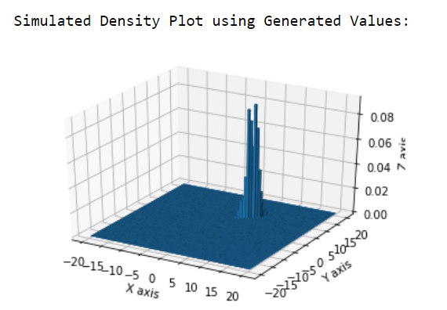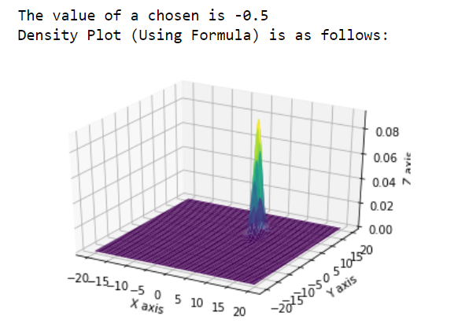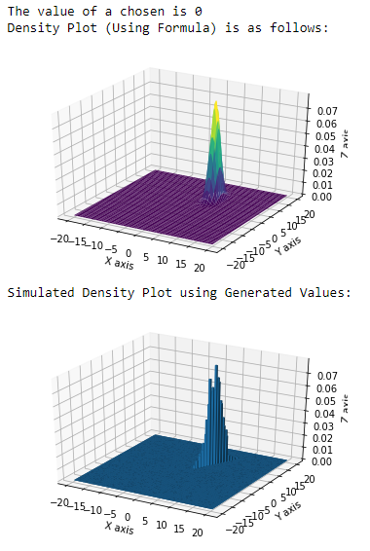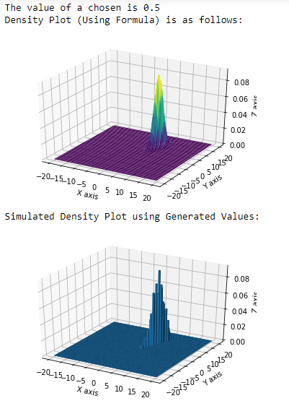

**Marginal Distributions:**

The generated sample values for X1 and X2 were stored separately in different arrays. Using these arrays, Simulated Marginal Distributions (X1 (X-axis) and X2 (Y-axis)) were obtained (using frequency histograms in python). Number of bins was set to 50. The simulated marginal density plot is represented by the blue bars.

X1 and X2 have been defined as follows:

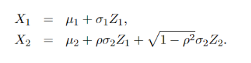

From the above formulas, it can be seen that:

E(X1) = µ1 = 5and Var(X1) = (σ1)2 = 1

E(X2) = µ2 = 8 and Var(X2) = (σ2)2 = 4

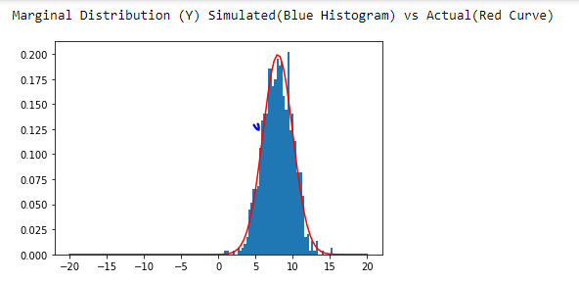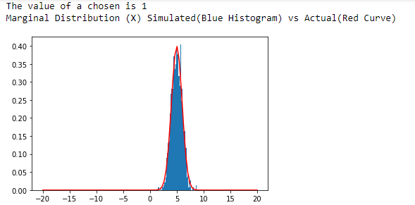Using the above values of mean and variance of normal distributions, actual marginal density plots were made (in the same graph in which the simulated plot was made) using scipy module in python. It can be observed that the actual and the simulated plots resemble each other (Not exact resemblance, because the number of generated values is just 1000). The plots obtained are as follows:

